# Software Engineering Project Abstract

**Problem Definition:** Design a software to automate the stock-investment process in way which is most profitable to the client.

**Features of Application:** The project is a software based on **Python-Tkinter** UI framework. The user has full control to either – automate or not. If the client selects the automated process, **ML** algorithms take care of the rest, otherwise it is done normally on a hand-to-hand interaction basis.

For UX, the software uses **Matplotlib-Live** graphs to help the client visualise the flow of his liquid capital and see various economic aspects of his/her investments.

**Process Model Employed:** The process employed here is **Evolutionary Model**. We wanted to employ this model because of the project's job segregation.

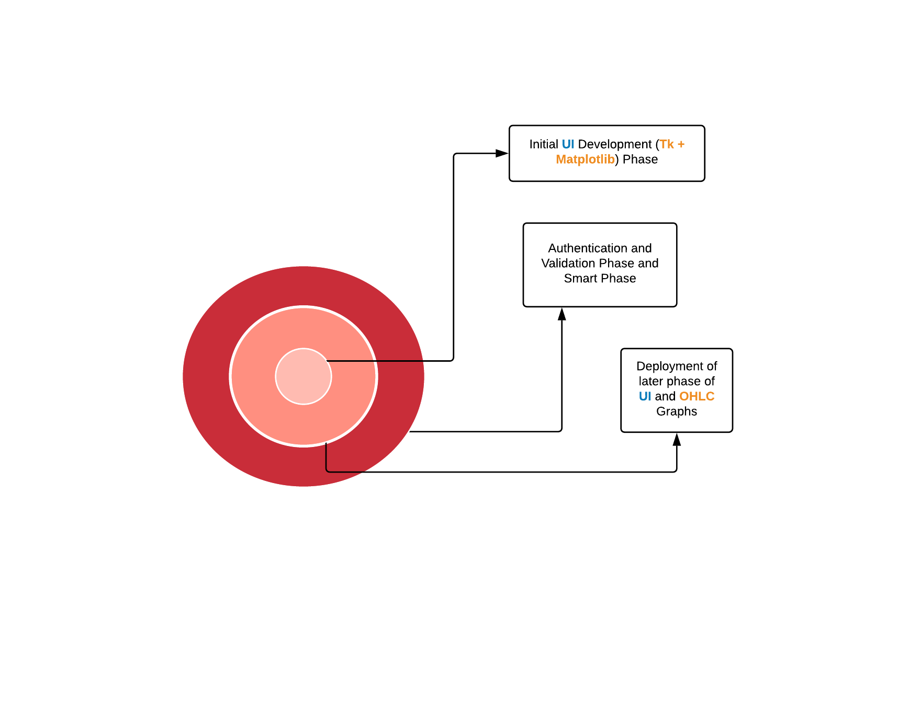

As it can be seen here, the entire phases of UI/UX and logical backend are independent.

So, employing this model was more rational and sensible and the others. The **Data-Flow-Diagram** would make it more clear.

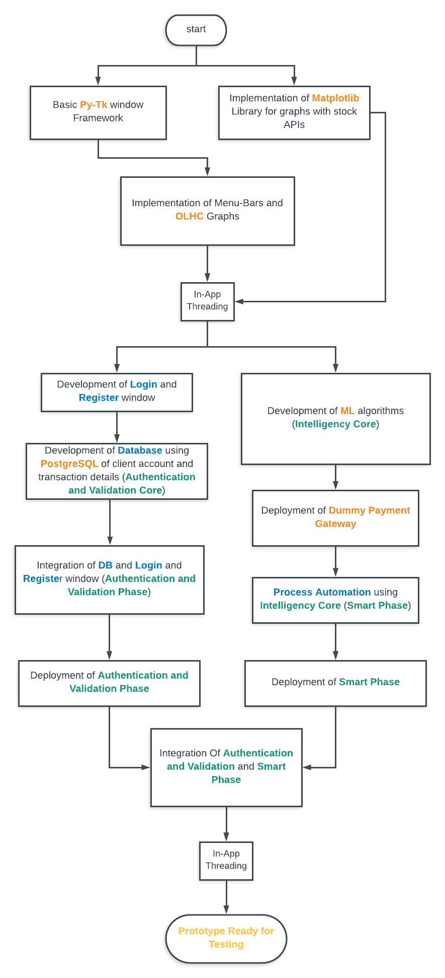

**Team Members:**

1. Akanksha Shrivastava CS-1 (1605006)
2. Aditya CS-1 (1605004)